Task

Top command : check process is running or not

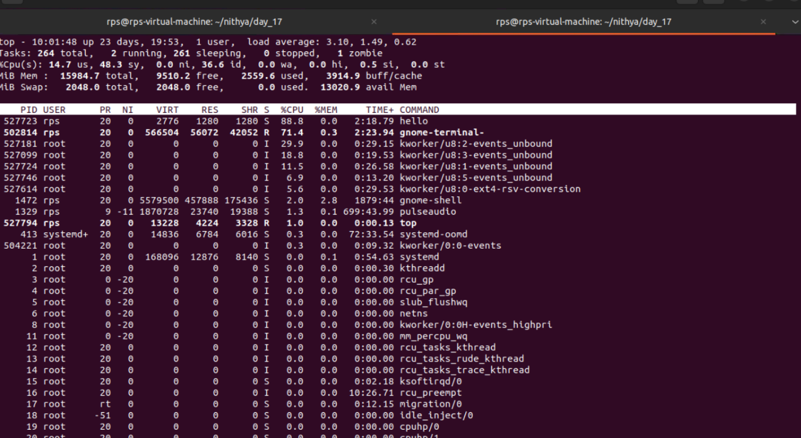

After process stop

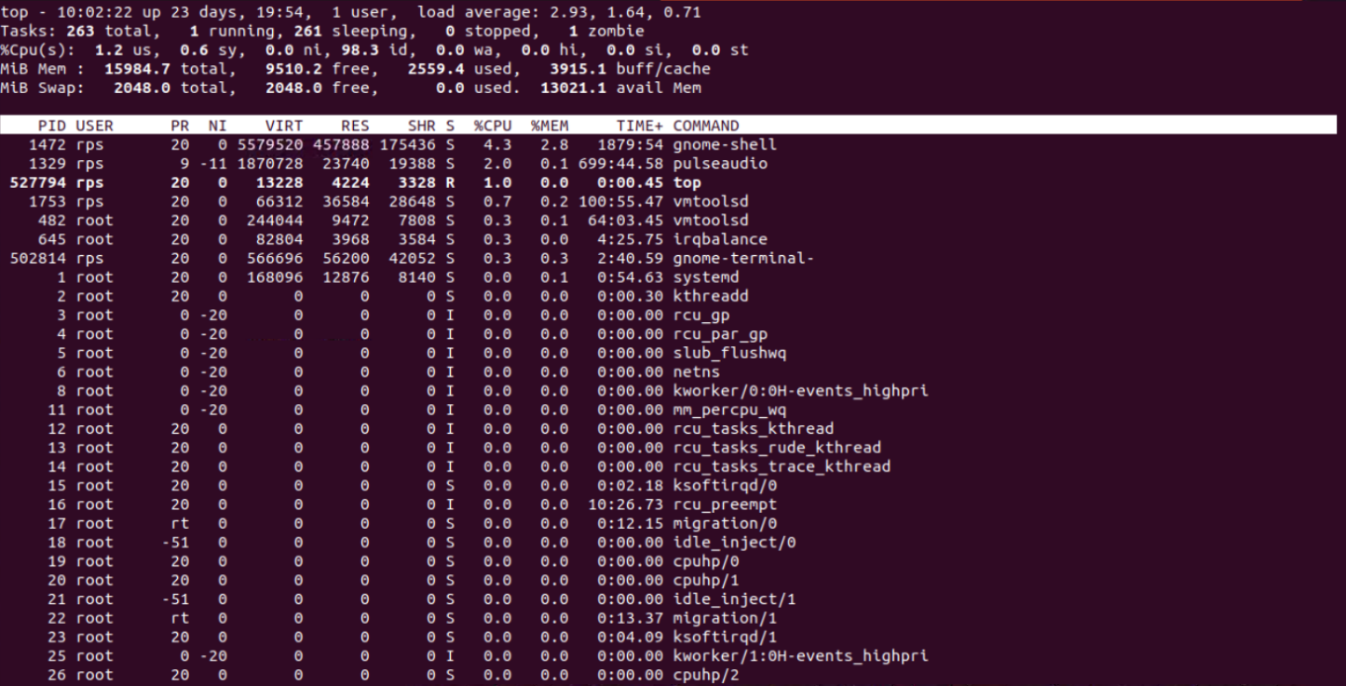

Kill command to stop the process

Before kill the process

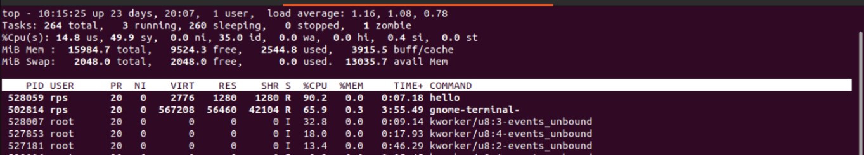

Killing process



After kill the process

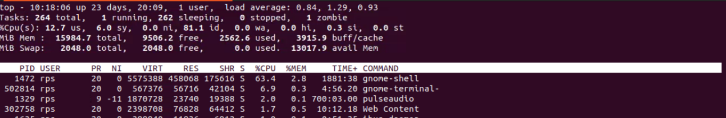

Example 1:

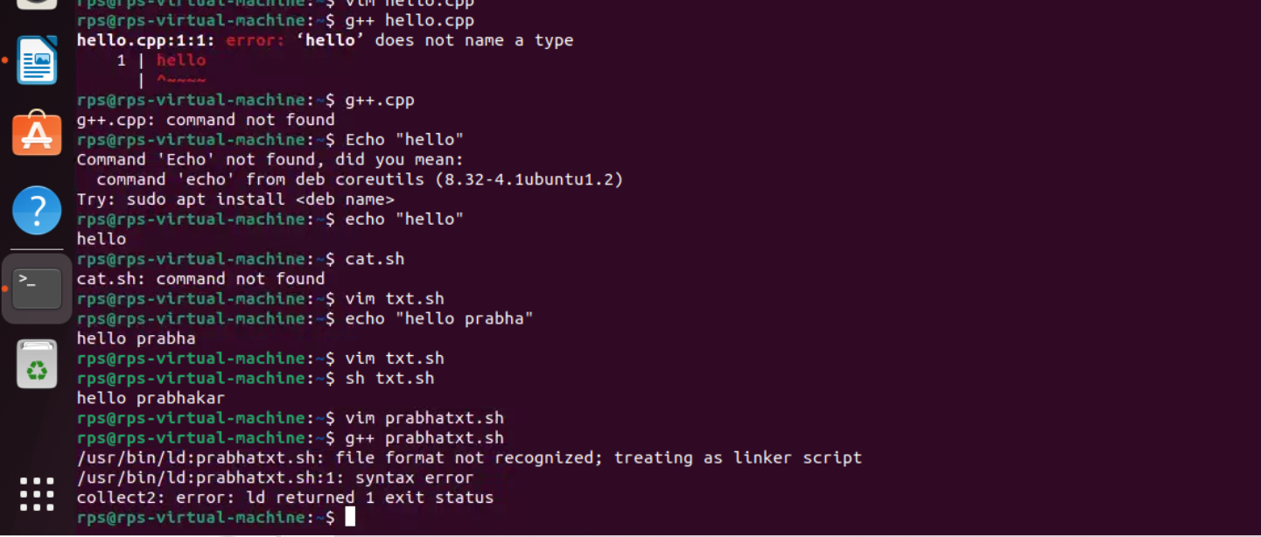Example 2:

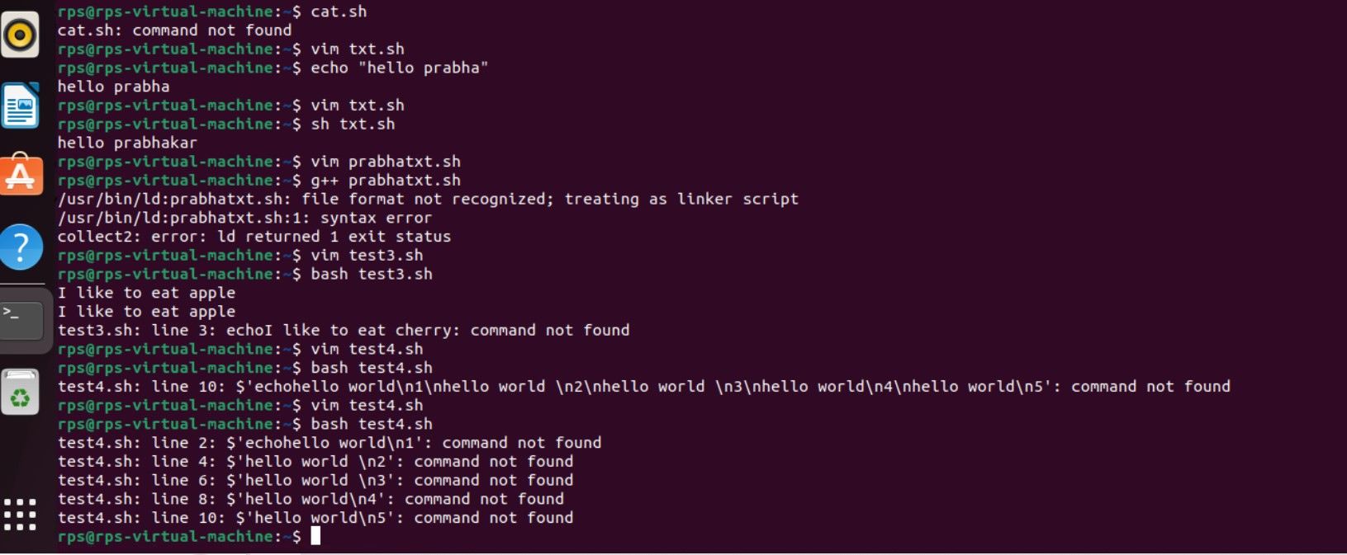

Example 3:

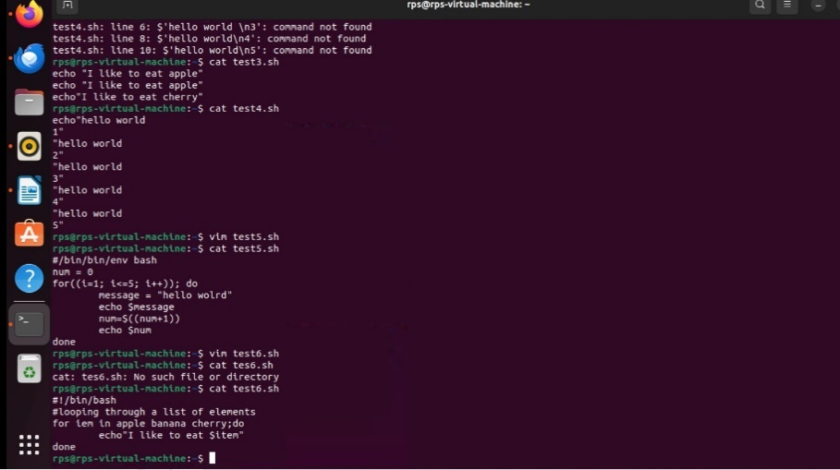

Example 4:

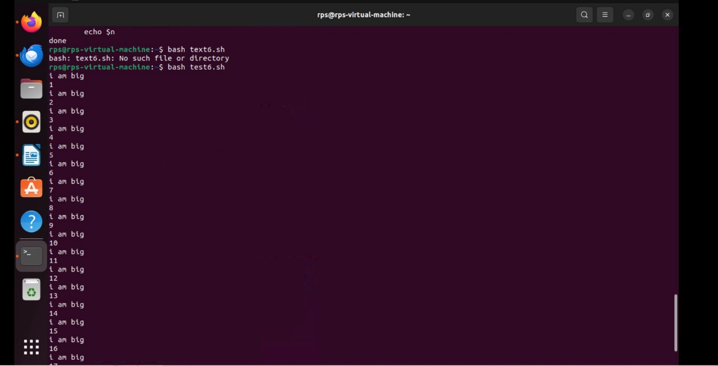

Example 5:

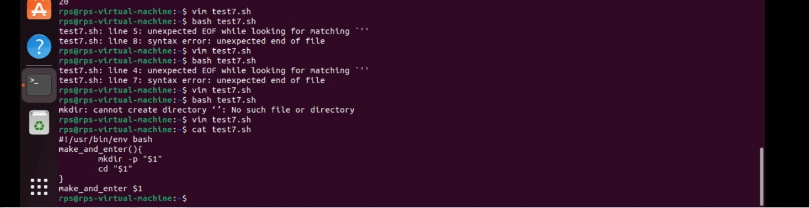

**File Search:**

**Write a command to find all files with the extension .txt in the /home directory and its subdirectories.:**

find /home -type f -name "*.txt"

**File Permissions:**

**Write a command to change the permissions of all files in the /var/log directory to 644.**

chmod 644 /var/log/*

**Disk Usage:**

**Write a command to display the disk usage of all directories in the /home directory in a human-readable format**.

du -h /home

**Process Management:**

**Write a command to list all running processes that contain the name "apache" in their command line.**

ps aux | grep "apache"

**Text Processing:**

**Write a command to count the number of lines in a file named error.log.**

wc -l error.log

**Network Configuration:**

**Write a command to display the IP address of all network interfaces on the system.**

ip addr show

**Package Management:**

**Write a command to install a package named htop using the package manager.**

sudo apt-get install htop

**User Management:**

**Write a command to add a new user named developer to the system.**

sudo adduser developer

**File Compression:**

**Write a command to compress a directory named backup into a .tar.gz file.**

tar -czvf backup.tar.gz backup

**System Monitoring:**

**Write a command to display real-time system resource usage, including CPU, memory, and disk I/O.**

Htop

**Shell Scripts**

**Backup Script:**

**Write a shell script to back up a directory named /data to /backup with the current date appended to the backup file name.**

#!/bin/bash

# Get current date

DATE=$(date +%Y%m%d)

# Create a backup

tar -czvf /backup/data_backup_$DATE.tar.gz /data

**Log Rotation:**

**Write a shell script to rotate log files in the /var/log directory, keeping only the last 7 days of logs.**

#!/bin/bash

# Find and delete log files older than 7 days

find /var/log -type f -mtime +7 -exec rm {} \;

**User Report:**

**Write a shell script to generate a report of all users currently logged into the system and save it to a file named user_report.txt.**

#!/bin/bash

# Get list of logged in users and save to user_report.txt

who > user_report.txt

**Disk Space Alert:**

**Write a shell script to check the disk usage of the /home directory and send an email alert if the usage exceeds 80%.**

#!/bin/bash

# Check disk usage of /home

USAGE=$(df /home | tail -1 | awk '{print $5}' | sed 's/%//')

# If usage exceeds 80%, send an email alert

if [ $USAGE -gt 80 ]; then

echo "Disk usage of /home is above 80%" | mail -s "Disk Space Alert" user@example.com

**Service Monitor:**

**Write a shell script to check if the nginx service is running and restart it if it is not.**

#!/bin/bash

# Check if nginx is running

if ! pgrep -x "nginx" > /dev/null; then

# Restart nginx if not running

sudo systemctl restart nginx

fi

**File Cleanup:**

**Write a shell script to delete all files older than 30 days in the /tmp directory.**

#!/bin/bash

# Delete files older than 30 days in /tmp

find /tmp -type f -mtime +30 -exec rm {} \;

**Automated Updates:**

**Write a shell script to automatically update all installed packages on the system.**

#!/bin/bash

# Update all installed packages

sudo apt-get update && sudo apt-get upgrade -y

**Database Backup:**

**Write a shell script to back up a MySQL database named sales to a file named sales_backup.sql.**

#!/bin/bash

# Backup MySQL database

mysqldump -u root -p sales > sales_backup.sql

**System Information:**

**Write a shell script to display system information, including hostname, OS version, and kernel version.**

#!/bin/bash

# Display system information

echo "Hostname: $(hostname)"

echo "OS Version: $(lsb_release -d | awk -F"\t" '{print $2}')"

echo "Kernel Version: $(uname -r)"

**Cron Job:**

**Write a shell script to schedule a cron job that runs a specific command every day at midnight.**

0 0 * * * /path/to/your/command

crontab -e